Name: Asim Nath Pant 
Student ID: 24071188
Program: BSc (Hons) Computing L3
Section: A
Module: Fundamentals of Data Science
Title: Bi-weekly Assignment: Assignment 4 (Week 7 & 8)

- Create a null vector of size 10 but the fifth value which is 1.

- Output:

- Ask user to input two numbers a, b. Write a program to generate a random array of shape (a, b) and print the array and avg of the array.

- Output:

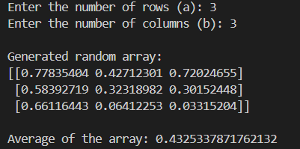

- Create a vector of size 10 with values ranging from 0 to 1, both excluded.

- Output:

- Can you create a identity matrix of shape (3,4). If yes write code for it.

- Output:

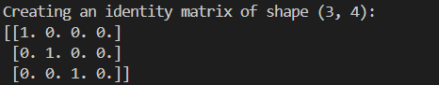
- Create a 5x5 matrix with row values ranging from 0 to 4.

- Output:

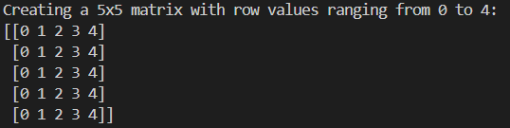

- Write a program to input an array of numbers from the user (at least 10 elements in list), sort them and perform slicing operations to get elements between indexes such as 2-5, 5-8, 2-9.

- Output:

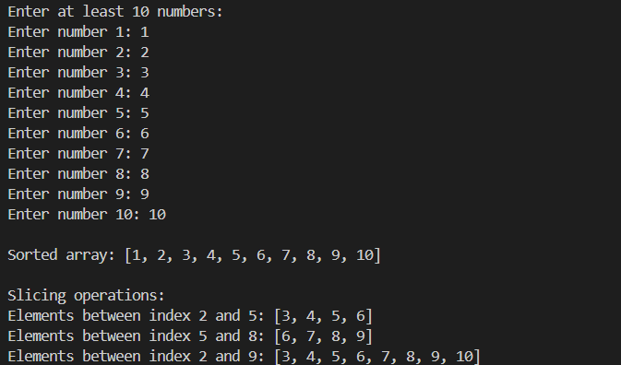

- Create an array of random integer numbers as a numpy array, sort them and perform operations such as reshaping of the array into matrix of feasible dimensions. (e.g., if we have an array of 1 * 10, then we can reshape it into 2 * 5 or 5 * 2 matrix.) [Hint: Use the array of reshape (row * column)] .

- Output:

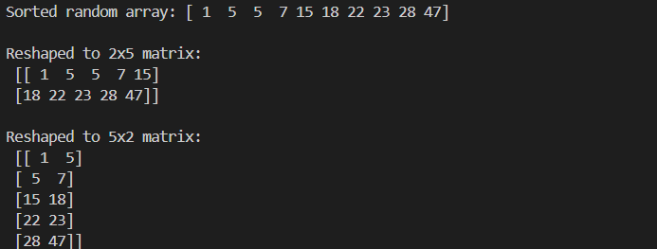

- Write a Pandas program to add, subtract, multiple and divide two Pandas Series.

- Output:

